**Cover Letter and Resume**

**Cover Letter:**

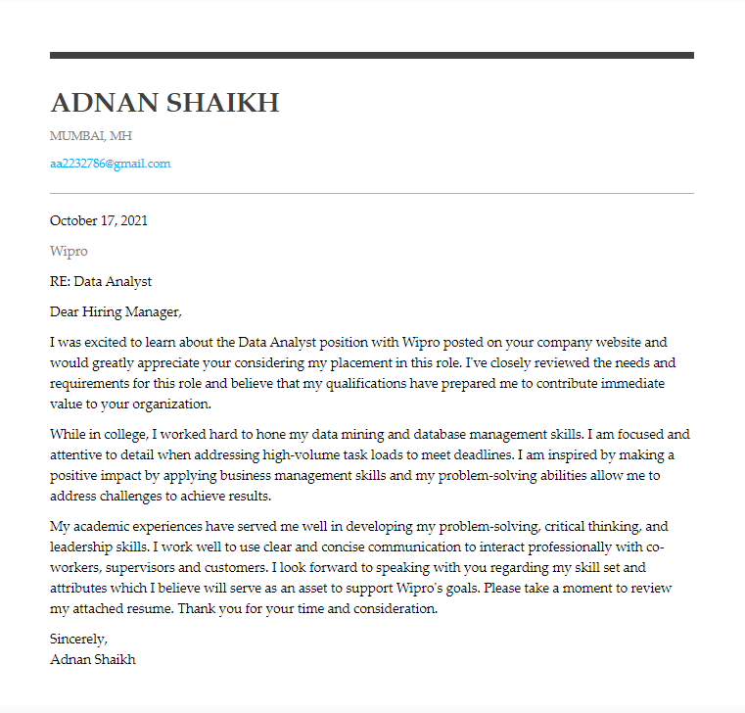

**Resume:**

